Acceptance Testing

bugFamily_outputs.txt

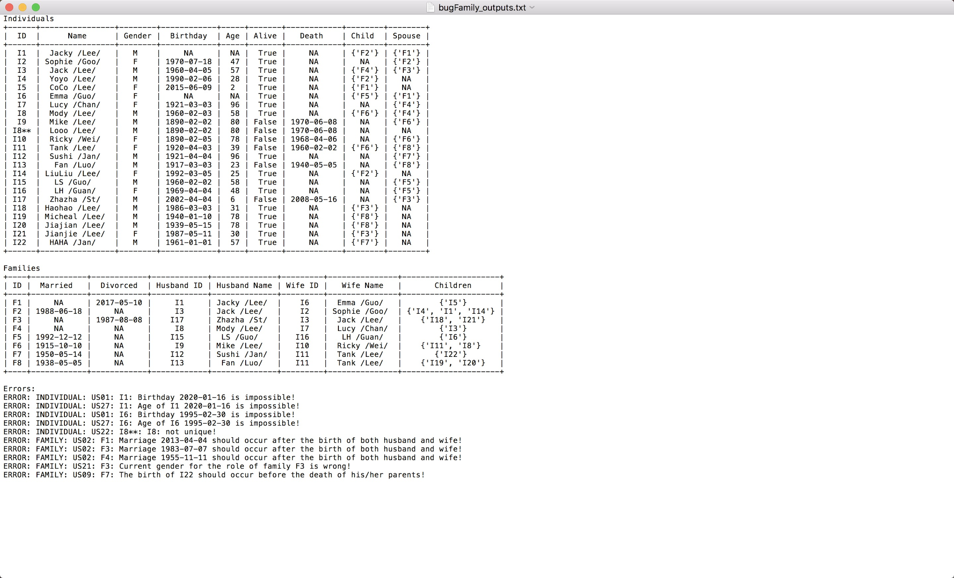

US01:

I1 Jacky Lee’s birthday is 2020-01-16 which is in the future.

For correct data, we did not print errors.

US02:

In F1, the marriage occurred before the birth of the husband.

In F3, the marriage occurred before the birth of the wife.

For correct data, we did not print errors.

In F4, the marriage occurred before the birth of the husband.

For correct data, we did not print errors.

US09:

In F7, the birth of I22 was 1961-01-01 which occurred after the death of Tank Lee 1960-02-02. It was impossible.

For correct data, we did not print errors.

US21:

In F3, the gender of both husband and wife are male. It is impossible.

For correct data, we did not print errors.

US22:

For I8 Looo Lee, his ID is not unique and same as Mody Lee.

For correct data, we did not print errors.

US27:

For I1, his age is unable to calculate.

For I6, his birthday is impossible so his age is also unable to calculate.

Other people’s ages are correct.

Family_outputs.txt

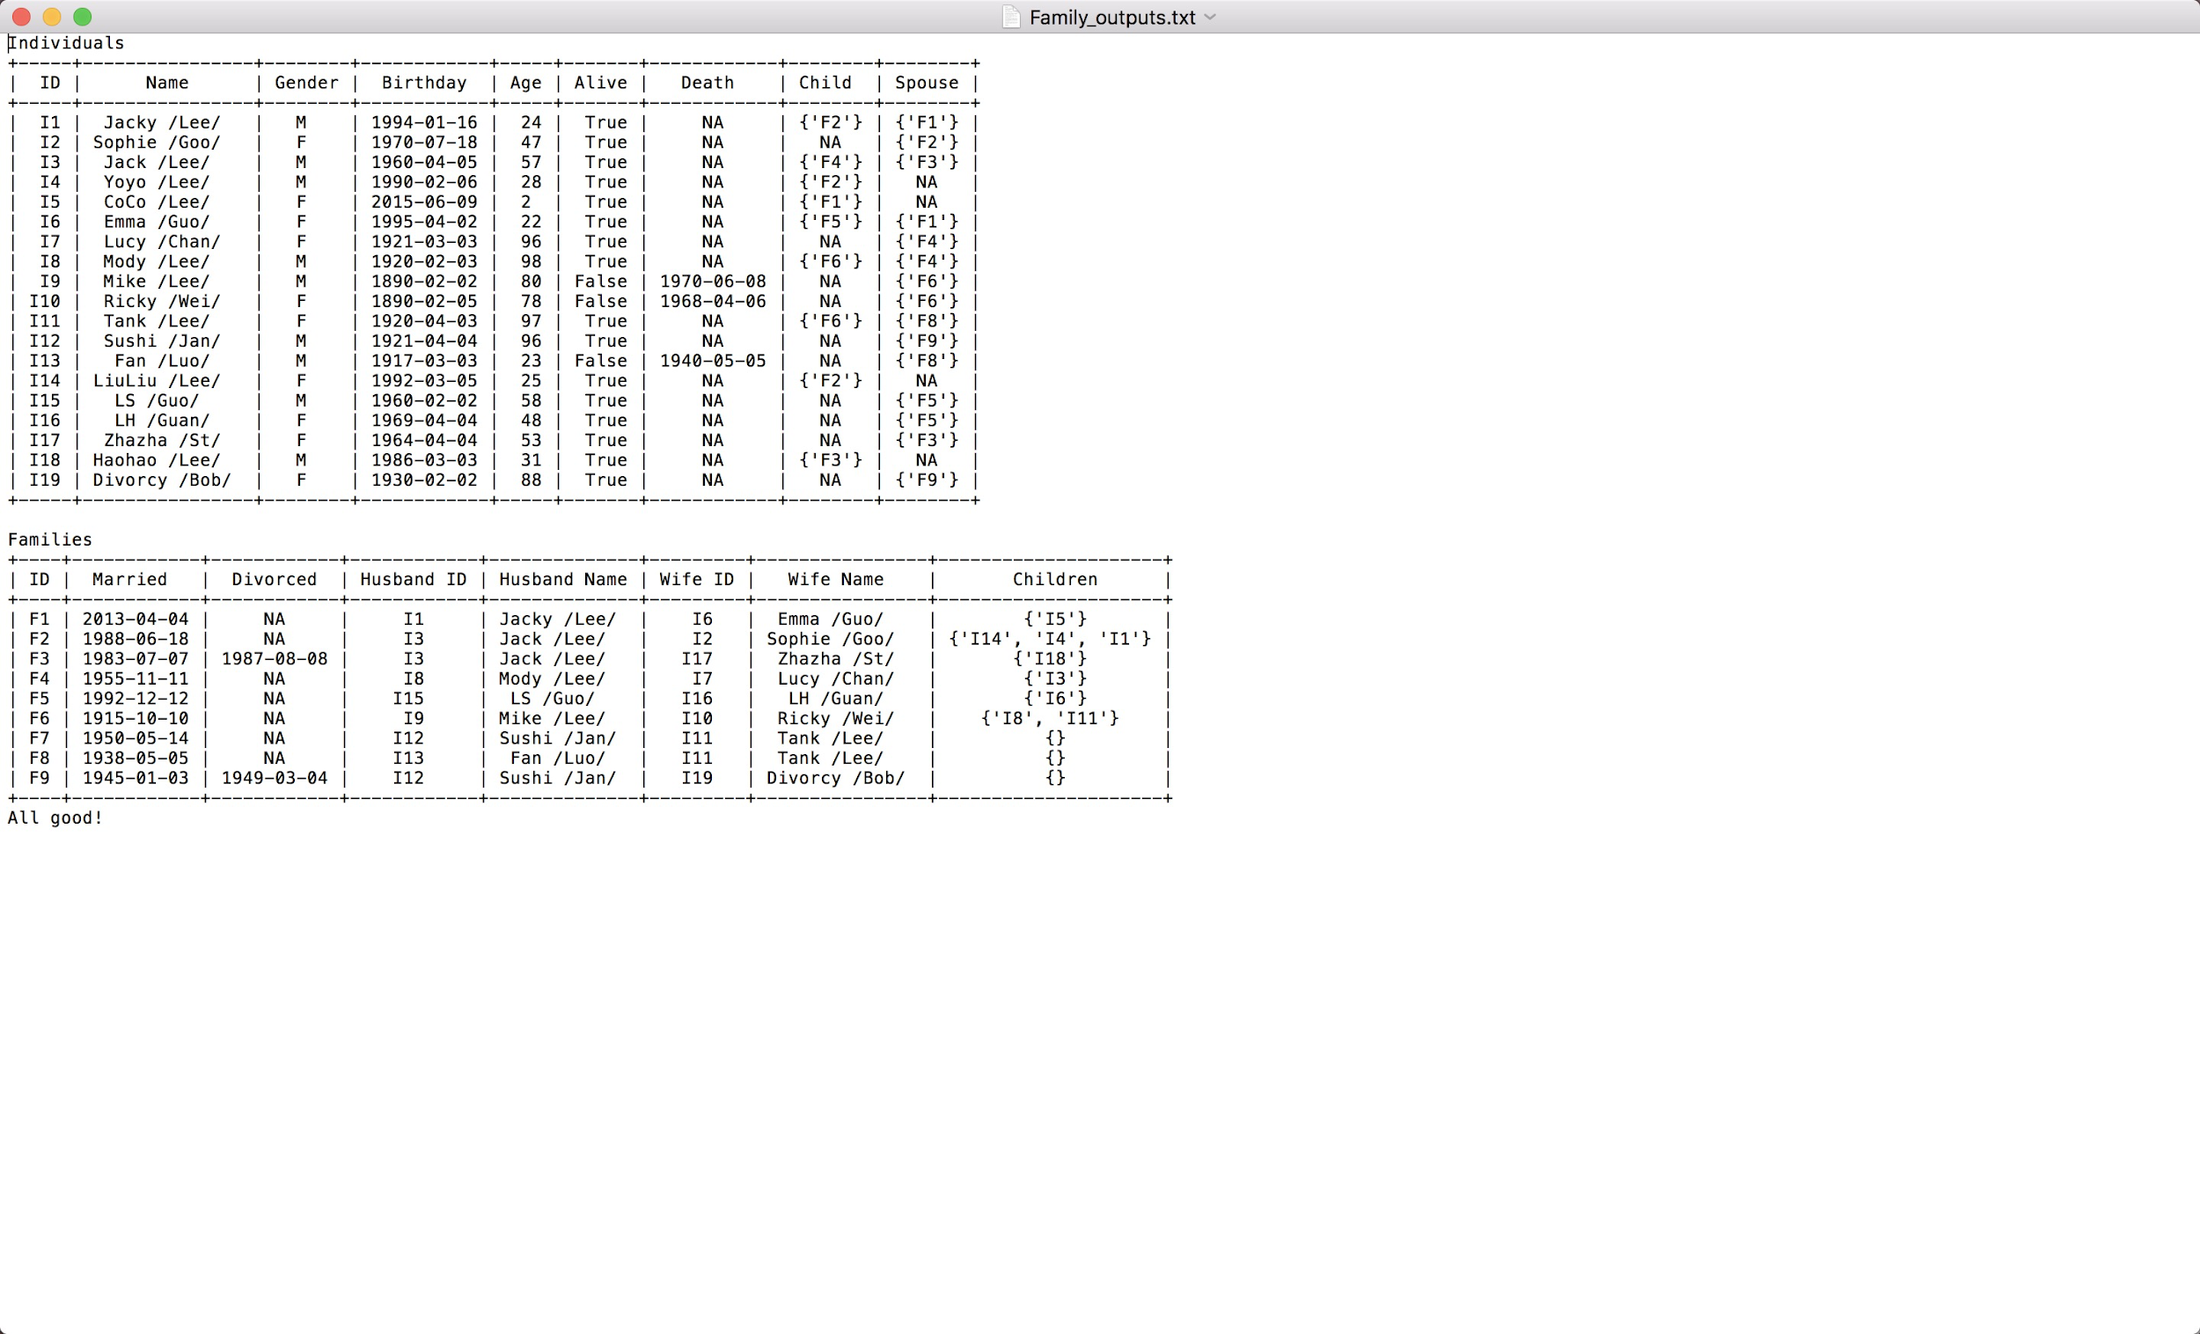

For correct file and data, we did not print any error.